Net user, list users on current machine

Net user /domain, on current domain

net user /domain | findstr 74600

net user rn74600 /domain

net user DefaultAccount /ACTIVE:YES

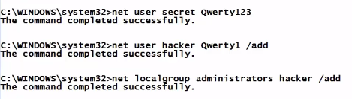

Change password, add user with password, add user to admin local group

**compmgmt.msc**